Audio One
Audio Two
Don’t forget to press play!
What you will learn from this worksheet is in line with The Piano Framework Beginners Level on Melody, part seven.

What you will learn from this worksheet:
- How to read a mini staff
- How to read patterns to do with pitch notation
- How to understand the relationship between sounds and symbols.
- Folk songs and Nursery Rhymes

A certificate is available for completing The Beginners’ Level part of The Piano Framework!

Guess the Music – Level One
Is this the score to Audio One or Audio Two?
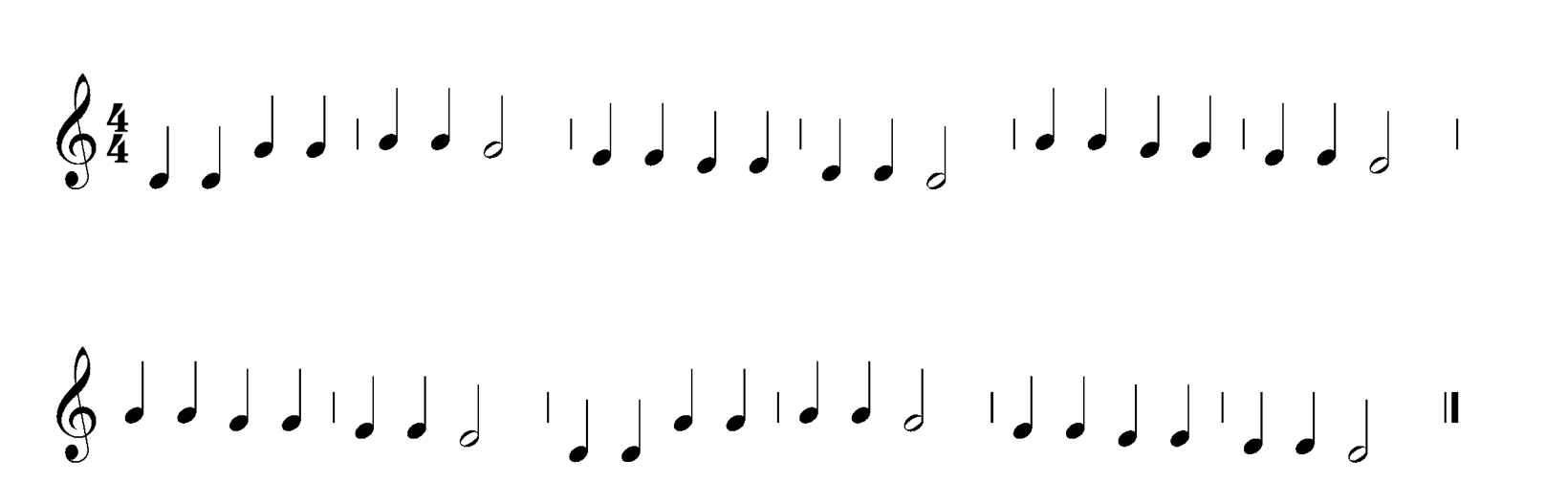

Choose the answer which applies to the above score

MINI STAVE Twinkle, Twinkle, Little, Star

GRAND STAVE Twinkle, Twinkle, Little, Star

MINI STAVE Mary Had A Little Lamb

GRAND STAVE Mary Had A Little Lamb

Is this the score for Audio One or Audio Two?

Which of these is the correct match?

MINI STAVE Twinkle, Twinkle, Little, Star

GRAND STAVE Twinkle, Twinkle, Little, Star

MINI STAVE Mary Had A Little Lamb

GRAND STAVE Mary Had A Little Lamb

Twinkle, Twinkle, Little, Star

Mary Had A Little Lamb

Twinkle, Twinkle, Little, Star

Mary Had A Little Lamb

