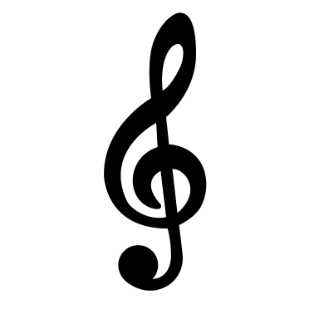

Listen to Piano Prelude Op. 28, No. 15 by Frédéric Chopin (1810—1849)

Answer these questions after you have listened:

- What is the pulse? Is it fast, medium or slow?
- What is the mood? Is it happy, sad or some other feeling?
- Why does it make you feel this way?

Which instrument do you hear?

Is it playing mainly legato or staccato?

Listen to Boléro by Maurice Ravel (1875—1937)

Answer these questions after you have listened:

- What is the pulse? Is it fast, medium or slow?
- What is the mood? Is it happy, sad or some other feeling?
- Why does it make you feel this way?

Can you hear the orchestra?

Which instruments do you hear?

Can you talk about what you hear?
Which musical words do you know? Use them to talk about the music.